HIGH VOLTAGE PIEZO DRIVER (model C)

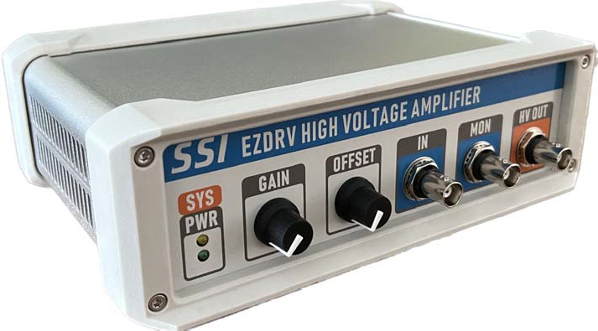

**FEATURES**

Single +24V DC Powered, 0-10V Analog Input High Voltage Amplifier

High Voltage Enable/Disable, GAIN, OFFSET, MONITORING features

Screw In Terminal Connectors, No Soldering Needed

Suitable for Capacitive Load like Piezo or Resistive Load

Metal Case with Bumpers

Active Cooling

All RoHS Components

Modulation Input Analog Input 0-10V, offset adjustable, 0.94uF load max 120Hz Triangle Wave within driving current limit

+24V

Power Supply

**SPECIFICATIONS**

Voltage Output 0-200Vpk-pk (3% max offset)

Max Output Current ± 45 mA with 0.94uF load

Cooling Active

Operating Temperature -20 – 35 C

Dimensions 55mm x 130mm x 200mm

Max Load Within max current load limit, capacitive or resistive

Bandwidth with resistive load 10KHz 0-10V Sine wave Input/100Vpp Sine wave Output

Monitor Output 0-10V : 0-200V

# Sample Results:

0.94 uF Capacitive Load with 120Hz Triangle Wave, 200V Output, 12 hours running

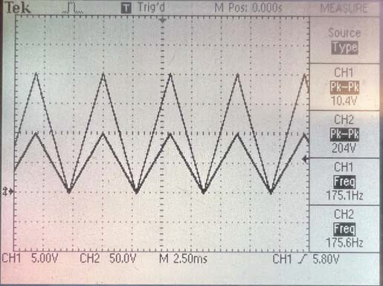

0.47 uF Capacitive Load with 175Hz Triangle Wave, 200V Output

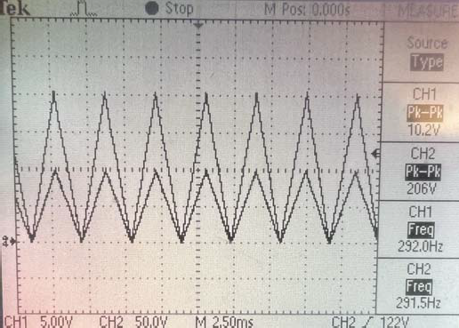

0.47 uF Capacitive Load with 292Hz Triangle Wave Input, 200V Output

# Calculate Driving Current:

1. Modulate with Triangle Wave I = ± 2*f*C_load*Vpk-pk

For example, the max current for 120Hz triangle modulation on 0.94uF load, 200Vpk-pk equals: 2*120*0.94e-6*200 = ±45mA

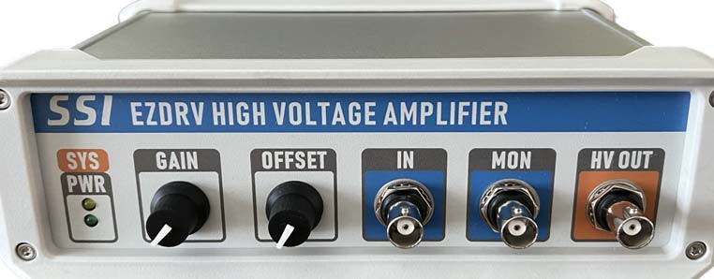

ORANGE: OK, WEAK ORANGE/FLASHING: ABNORMAL

SYS LED (UPPER)

**FRONT PANEL WIRING SPECIFICATIONS**

PWR LED (LOWER) GREEN: OK

GAIN GAIN ADJUSTABLE

OFFSET OFFSET ADJUSTABLE

IN 0-10V SMALL SIGNAL BNC INPUT

MON 0-10V : 0-200V MONITOR SIGNAL BNC OUTPUT

HV OUT 0-200V/+-45mA RMS HIGH VOLTAGE BNC OUTPUT

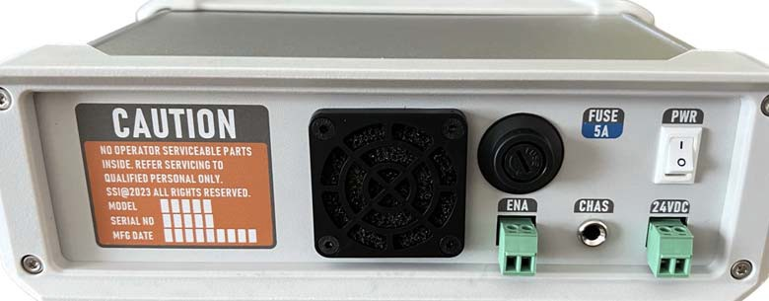

+24VDC Power Supply, RIGHT PIN +; LEFT PIN return

24VDC

**REAR PANEL WIRING SPECIFICATIONS**

ENA EN: float or GND

DISABLE: SHORT

CHAS METAL ENCLOSURE, NO INTERNAL CONNECTION

FUSE 5AMP, Consult Factor Before Replace

PWR POWER SWITCH

Quotation on order of large quantity:

Email: [smartsensinginternational@gmail.com](mailto:smartsensinginternational@gmail.com)

Telephone: 978-494-0802 msg